**Goblins Tire Change (9/22/2022)**

Goblins tend to wear the tires, especially the front tires, at a rate that after a few races, it may be time to change to a new tire. As of this writing, tires from Green Power are backordered but the Chattanooga Green Prix team has found a suitable substitute for the interim. It is a two-ply tire and does wear a bit quicker than the original but will still get you on track!

The tires come from Harbor Freight. There are physical stores at 5839 Brainerd Rd, and one at 4860 Hixson Pike. Below is a picture and link to the tire: <https://www.harborfreight.com/10-inch-knobby-tire-43612.html>. Another acceptable tire is number is 40729: <https://www.harborfreight.com/heavy-duty-10-inch-groove-tread-tire-40729.html>.

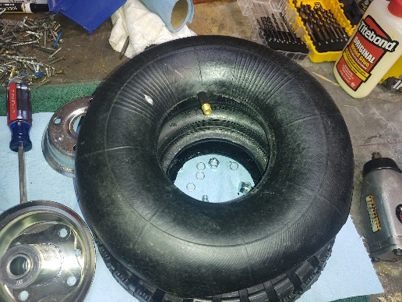

The Harbor Freight wheels is a two-piece wheel so you can undo the 4 bolts and split the wheel to get the tire. The inner tube that comes with the wheel is not usable as it does not have the angled section of the original—SAVE YOUR ORIGINAL INNER TUBES!

Also, the Harbor Freight wheel has a smaller axle size so YOU WILL NEED TO REUSE THE RED WHEEL. Basically, you are just using the tire from the Harbor Freight wheel.

Now that you have the new tire, it is time to swap it to the Red wheel.

1. Fully deflate the tire.
2. Put a bit of soapy water on the Red wheel around the tire bead (where the tire meets the wheel) to ease removal of the old tire.
3. Carefully pry the tire over the bead of the Red wheel. Make sure you do not pinch the inner tube doing this. What I found works best is work the tire off to about ½ of the radius by hand, then get a stout screwdriver or tire iron to pry off the second half. Four hands help! Again—do not pinch the inner tube!
4. Remove the tire from the wheel. Once the first side comes off, you may be able to slide out the inner tube and removing the tire from the wheel is much easier.



1. Use the old inner tube. Place it inside the new tire either before mounting or after getting the first side on to the wheel and feeding inside the tire. Check the alignment of the valve stem and the hole in the wheels before getting the second side of the tire mounted.
2. It is possible you will gouge the wheel during dismount. Not a problem as long as you do not break the wheel. The inner tube is what gives the tire its pressure.

7. Adding air—otherwise known as cursing and throwing tools. The valve stem, even with the angled section, does not really give enough room to get an air chuck on the end. I HIGHLY recommend a set of 4 valve stem extenders. They sell them at Walmart and here is a link to the same set sold on Amazon.

<https://www.amazon.com/Slime-2045-Metal-Valve-Extenders/dp/B003V9TC10/ref=sr_1_3?keywords=valve+stem+extenders&qid=1663865750&sr=8-3>

8. If you want to go the *yelling at the tire* route—it helps to push on the valve stem from the back side, just watch pinching you fingers between the wheel and tire as it can rapidly inflate (ask me how I know). Also be very mindful that these small tires inflate quickly and are easy to overinflate. Check the sidewall for max pressure (30PSI).

9. Last link. If you do tear the inner tube beyond the ability to patch with a bicycle tire patch, you can get new ones—something like this should work: <https://www.amazon.com/3-00-4-Mobility-Scooter-Chopper-Minimoto/dp/B0762JR82P/ref=sr_1_4?crid=1ZSCNAWYSXIIP&keywords=makuro%2B3.00-4&qid=1663866031&sprefix=makuro%2B3.00-4%2Caps%2C80&sr=8-4&th=1>

10. All goes well, you will have something that looks like this! Oh, and do not lose the roller bearing inside the wheel!

If you need some help with tire changes, contact Madison at Green Spaces and she will get someone from Green Prix to help.

